CST 334 (Operating Systems)

Dr. Glenn Bruns

# Lab: file and directory permissions

There are hints at the end of the lab, but try hard to solve by memory first.

1. Start a bash shell and look at the permissions of the files in your home directory.
2. Direct the output of command ls -l to a file called mydir.txt.
3. Look at the permissions of mydir.txt.
4. Modify the permissions of mydir.txt so only you (the file owner) can read it.
5. Modify the permissions of mydir.txt so you can read and write it, but everyone else can only read it.
6. Delete mydir.txt, then repeat item 2 above to re-create mydir.txt
7. What groups do you belong to?
8. What is your current group?
9. Using octal mode, change the permissions of mydir.txt to 460. Explain what 460 means.
10. What is the group associated with mydir.txt?
11. Try appending some text to the end of mydir.txt. What happens? Explain why.
12. Create a subdirectory of your home directory called mydir.
13. Copy a C file you’ve written into that directory. Rename the file to foo.c.
14. Set the permissions of mydir so that you have read and write, but no execute permissions. Try doing the following things on mydir (all from your home directory), and record whether or not you can do it.
    * enter it ($ cd mydir)
    * see the files in it ($ ls mydir)
    * write a file into it ($ touch mydir/temp.txt)
    * read a file in it ($ cat foo.c)
    * edit a file in it (using vim or nano, for example)
    * rename a file in it ($ mv foo.c foo1.c)

Put the results of your test into the first column of a table like this:

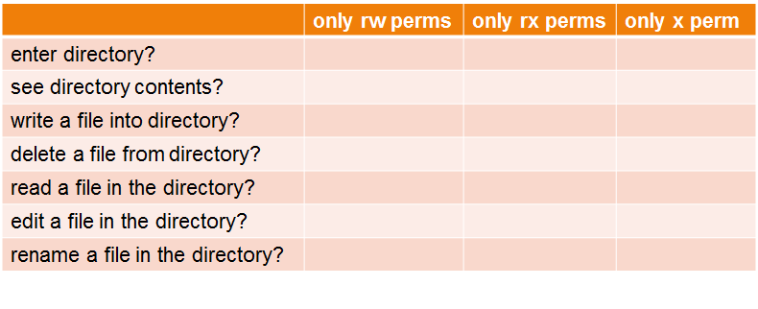

1. Now set of the permissions of mydir so that you have read and execute, but no write permission, and run all the tests again (you may have to restore to contents of mydir to what they were before the last problem.). Record whether or not you can do each one.
2. Repeat the tests again, but this time with only execute permission on mydir.

Hints:

1. Use ls -l
2. ls -l > mydir.txt
3. See 3 above.
4. For example, use chmod 600 mydir.txt
5. For example, use chmod 644 mydir.txt
6. -
7. Use command groups to see the groups you belong to.
8. Use command id -g -n to see your current group.
9. -
10. Is it your current group?
11. You can not write to the file, because you are being treated as the owner of the file, and the owner does not have write permission. This is true even though your current group is the group of the file, and you belong to the group. At any time you will be treated as only one of user, group, or other.
12. -
13. -
14. -
15. -
16. -